02.07 Digital Records
Process Design & AMOS Configuration Document
Purpose
This Process Design document is provided to Key-Users to record their key decisions regarding the AMOS Process design and the required AMOS configuration.
It is updated throughout the Project Definition Phase and used as the baseline for the Final Acceptance prior to Go-Live
Revision
Author, Name | Date | Notes
Jakub Sadowski | 01.06.2024 | First Version
Pradeep Pathirana | 23.05.2025 | Second Version

Process Overview & Objectives
Process General Description:
This process describes possible scenarios of capturing data in digital form in AMOS (MX, parts, and other retained records).
Main Process Objective (Outputs & Outcomes):
Digital-native or digitized data present in AMOS system after certain actions in master processes are triggered.

Regulatory References

M.A.614 Maintenance and airworthiness review records
The approved maintenance organisation shall provide a copy of each CRS to the aircraft owner or operator, together with a copy of any detailed maintenance records associated with the work carried out and necessary to demonstrate compliance with point M.A.305 of this Annex (Part-M) or ML.A.305 of Annex Vb (Part-ML), as applicable.
145.A.42 Components b) Components, standard parts and materials for installation
(i) The organisation shall establish procedures for the acceptance of components, standard parts and materials for installation to ensure that components, standard parts and materials are in satisfactory condition and meet the applicable requirements of point (a).
(ii) The organisation shall establish procedures to ensure that components, standard parts and materials shall only be installed on an aircraft or a component when they are in satisfactory condition, meet the applicable requirements of point (a) and the applicable maintenance data specifies the particular component, standard part or material.

Definitions & Glossary
Key-Words | Explanation
AIM | Adaptive Integration Manager
FAA | Federal Aviation Authority
MRO | Maintenance, Repair and Overhaul
ACC | AMOS competence center

Process Tasks

This is only a Support process

Process Dependencies
INPUT | CONCURRENT | OUTPUT
08.02 Performing Maintenance  08.04 Parts Removal & Installation  08.05 Release to Service  10.02 Goods Receiving and Inspection  FLYDOCS1 SCANNED PAPERWORK EARCHIVING  04.05 Quality Auditing | FLYDOCS1 SCANNED PAPERWORK EARCHIVING

Process Flow
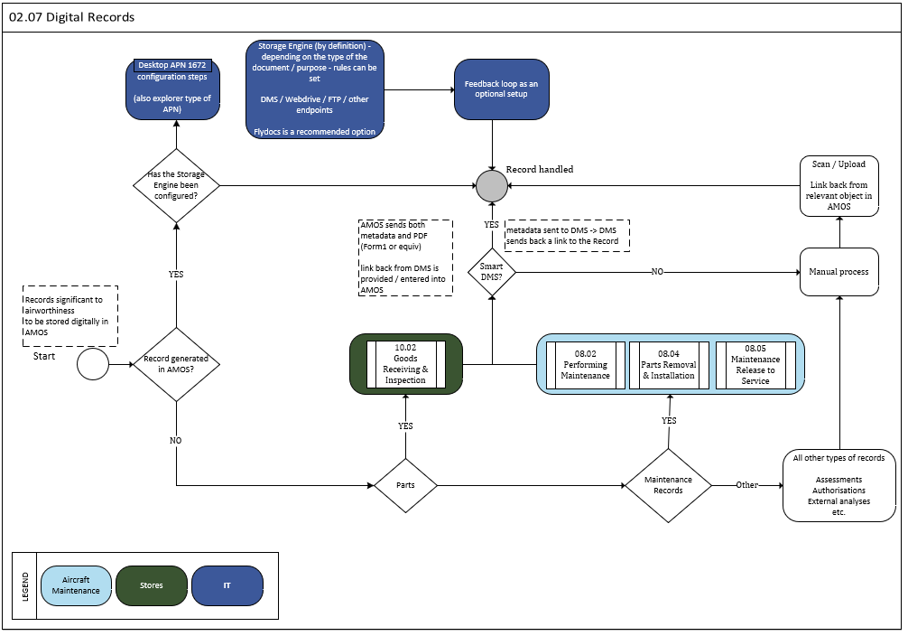

Process Design Questions
# | Question | Answer
 | Do you use or intend to use any Document Management System?
 | How are Maintenance records going to be updated in AMOS?
 | Do you need to store information about received parts in any external storage solution/systems?
 | Do you need to store any other kind of data in other modules as a linked objects, PDFs, web-drive files?

Data Source Mapping
Data Sources | Description | Volume / Manual / Automatic / Static / Dynamic

Other Software Used
Other Software | Used by: | Description
-/- | -/- | -/-

AMOS Configuration

Process specific configuration programmes
AMOS APN | Notes
APN 1672 Storage Engine Manager | Defines Storage Engine used to exchange information with AMOS
APN 1404 AIM Configuration | Configuration of import/export interfaces

Basic Data
Basic Data Table | Notes
N/A

Parameters
Parameter Code | Parameter Name | Notes
1525 | IXOS STORE DOC SCRIPT | Enter the url to the Amount[String] value that is used to store a document in a Document Management System.  E.g.: http://ixosserver/store.asp
1527 | JCR ENABLED | Enable or disable the JCR engine.  Set the Amount[String] to " Y" to enable the engine, "N" disables the engine.
1528 | JCR CONFIG FILE | This parameter is only relevant if parameter 1527 has a string value = `Y`.  It specifies where the JCR configuration file is located.  This is used in Storage Engine and can be configured in APN1672.
1783 | Associate AMOS link with actual owner type | In Storage Engine (APN:1672),  by default, all files attached through the AMOS link dialogue always have the Owner Type = LINK.  When the parameter is set to ‘Y’ , files attached via below mechanism will have actual Owner type and Owner key linked in Storage Engine .  A local file is uploaded through the AMOS link dialogue.  A document is Scanned via the Link Button.
1395 | TURN AIM LOGGING ON/OFF | Turn the AIM-logging ON or OFF.  Integer-value set to 0: Logging is off (default)  Integer-value set to 1 (or greater): Logging is on  String value set to `L`: pre-AMOS 22.12 handling of AIM Logs with important database IO.  String value empty or set to anything else: new AMOS 22.12 handling of AIM Logs with potentially reduced database IO.
1783 | Associate AMOS link with actual owner type | In Storage Engine (APN:1672),  by default, all files attached through the AMOS link dialogue always have the Owner Type = LINK.
1433 | OPEN SCAN DIALOG AFTER RECEIVING | If this parameter is configured the system automatically opens a scan dialog after the part has been received or after the inspection of a released rotable. The scanned documents are linked to the receiving and in case of receiving or inspection of a release of a rotable also to the rotable.

Workflows
Workflow Number | Workflow Name | Workflow Setup Notes
33 | Workorder closed (post-save)
100 | Workorder saved (post-save)
98 | After saving, deleting and creating a workpackage
158 | After De-assigning Events from a Workpackage
370 | After Assigning Events to a Workpackage
411 | After a W/P event is closed, deferred or marked as not performed | flydocs - WP released to prod / edited

Scheduled Tasks
Scheduled Task Reference | Frequency | Notes
Export Task | Every 10 minutes | Only needed if the export of stand-alone workorders should be triggered by scheduler rather than workflow-action.
StorageEngineLinksMigrationTask

API’s & Interfaces
Reference | Direction | Trigger | Frequency
Transfer MRO (Maintenance, Repair and Overhaul) workpackage | Export | Workflow-action | Action triggered
Transfer workorder | Export | Workflow-action | Action triggered
Transfer scan | Import | Webservice | Triggered externally

UAT Guidance
Test case number | Test case description | Required data | Required resources
T02.07.01 | Check transfer of metadata and PDF after Part receiving
T02.07.02 | Check transfer of MX records to DMS (and backlink presented to AMOS by DMS)

Annex – Additional Info
-/-

